La siguiente imagen representa el contenido del archivo blanco.bmp en formato hexadecimal; analice cada uno de los campos de las diferentes cabeceras, y escríbalos en el lugar que le corresponda del archivo BMP.doc.

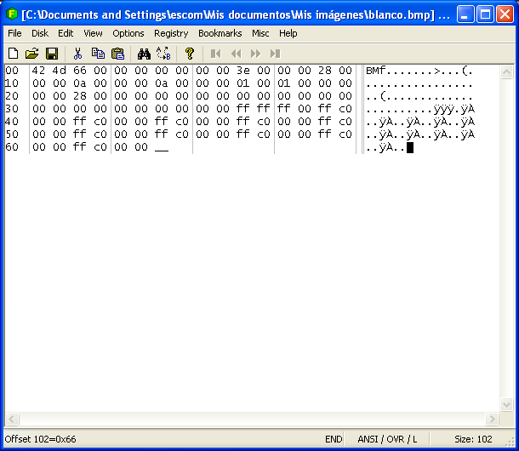

Basic File Format
Name |  |  | Size | Description
Header |  |  | 14 bytes | Windows Structure: BITMAPFILEHEADER
 | Signature |  | 2 bytes | 'BM'
 | FileSize |  | 4 bytes | File size in bytes
 | reserved |  | 4 bytes | unused (=0)
 | DataOffset |  | 4 bytes | File offset to Raster Data
InfoHeader |  |  | 40 bytes | Windows Structure: BITMAPINFOHEADER
 | Size |  | 4 bytes | Size of InfoHeader =40
 | Width |  | 4 bytes | Bitmap Width
 | Height |  | 4 bytes | Bitmap Height
 | Planes |  | 2 bytes | Number of Planes (=1)
 | BitCount |  | 2 bytes | Bits per Pixel  1 = monochrome palette. NumColors = 2  4 = 4bit palletized. NumColors = 16  8 = 8bit palletized. NumColors = 256  16 = 16bit RGB. NumColors = 65536 (?)  24 = 24bit RGB. NumColors = 16M
 | Compression |  | 4 bytes | Type of Compression  0 = BI_RGB no compression  1 = BI_RLE8 8bit RLE encoding  2 = BI_RLE4 4bit RLE encoding
 | ImageSize |  | 4 bytes | (compressed) Size of Image
 | It is valid to set this =0 if Compression = 0
 | XpixelsPerM |  | 4 bytes | horizontal resolution: Pixels/meter
 | YpixelsPerM |  | 4 bytes | vertical resolution: Pixels/meter
 | ColorsUsed |  | 4 bytes | Number of actually used colors
 | ColorsImportant |  | 4 bytes | Number of important colors 0 = all
 | ColorTable |  | 4 * NumColors bytes | present only if Info.BitsPerPixel <= 8
colors should be ordered by importance
 |  | Red | 1 byte | Red intensity
 |  | Green | 1 byte | Green intensity
 |  | Blue | 1 byte | Blue intensity
 |  | reserved | 1 byte | unused (=0)
 | repeated NumColors times
Raster Data |  |  | Info.ImageSize bytes | The pixel data

Raster Data encoding
Depending on the image's BitCount and on the Compression flag there are 6 different encoding schemes. All of them share the following:
Pixels are stored bottom-up, left-to-right. Pixel lines are padded with zeros to end on a 32bit (4byte) boundary. For uncompressed formats every line will have the same number of bytes. Color indices are zero based, meaning a pixel color of 0 represents the first color table entry, a pixel color of 255 (if there are that many) represents the 256th entry. For images with more than 256 colors there is no color table.

Raster Data encoding for 1bit / black & white images
BitCount = 1 Compression = 0
Every byte holds 8 pixels, its highest order bit representing the leftmost pixel of those. There are 2 color table entries. Some readers will ignore them though, and assume that 0 is black and 1 is white. If you are storing black and white pictures you should stick to this, with any other 2 colors this is not an issue. Remember padding with zeros up to a 32bit boundary (This can be up to 31 zeros/pixels!)

Raster Data encoding for 4bit / 16 color images
BitCount = 4 Compression = 0
Every byte holds 2 pixels, its high order 4 bits representing the left of those. There are 16 color table entries. These colors do not have to be the 16 MS-Windows standard colors. Padding each line with zeros up to a 32bit boundary will result in up to 28 zeros = 7 'wasted pixels'.

Raster Data encoding for 8bit / 256 color images
BitCount = 8 Compression = 0
Every byte holds 1 pixel. There are 256 color table entries. Padding each line with zeros up to a 32bit boundary will result in up to 3 bytes of zeros = 3 'wasted pixels'.

Raster Data encoding for 16bit / hicolor images
BitCount = 16 Compression = 0
Every 2bytes / 16bit holds 1 pixel.
The pixels are no color table pointers. There are no color table entries. Padding each line with zeros up to a 16bit boundary will result in up to 2 zero bytes.

Raster Data encoding for 24bit / truecolor images
BitCount = 24 Compression = 0
Every 4bytes / 32bit holds 1 pixel. The first holds its red, the second its green, and the third its blue intensity. The fourth byte is reserved and should be zero. There are no color table entries. The pixels are no color table pointers. No zero padding necessary.

Raster Data compression for 4bit / 16 color images
BitCount = 4 Compression = 2
The pixel data is stored in 2bytes / 16bit chunks. The first of these specifies the number of consecutive pixels with the same pair of color. The second byte defines two color indices. The resulting pixel pattern will be interleaved high-order 4bits and low order 4 bits (ABABA...). If the first byte is zero, the second defines an escape code. The End-of-Bitmap is zero padded to end on a 32bit boundary. Due to the 16bit-ness of this structure this will always be either two zero bytes or none.
n (byte 1) | c (Byte 2) | Description
>0 | any | n pixels are to be drawn. The 1st, 3rd, 5th, ... pixels' color is in c's high-order 4 bits, the even pixels' color is in c's low-order 4 bits. If both color indices are the same, it results in just n pixels of color c
0 | 0 | End-of-line
0 | 1 | End-of-Bitmap
0 | 2 | Delta. The following 2 bytes define an unsigned offset in x and y direction (y being up) The skipped pixels should get a color zero.
0 | >=3 | The following c bytes will be read as single pixel colors just as in uncompressed files. up to 12 bits of zeros follow, to put the file/memory pointer on a 16bit boundary again.

Example for 4bit RLE
Compressed Data | Expanded data
03 04 | 0 4 0
05 06 | 0 6 0 6 0
00 06 45 56 67 00 | 4 5 5 6 6 7
04 78 | 7 8 7 8
00 02 05 01 | Move 5 right and 1 up. (Windows docs say down, which is wrong)
00 00 | End-of-line
09 1E | 1 E 1 E 1 E 1 E 1
00 01 | EndofBitmap
00 00 | Zero padding for 32bit boundary

Raster Data compression for 8bit / 256 color images
BitCount = 8 Compression = 1
The pixel data is stored in 2bytes / 16bit chunks. The first of these specifies the number of consecutive pixels with the same color. The second byte defines their color index. If the first byte is zero, the second defines an escape code. The End-of-Bitmap is zero padded to end on a 32bit boundary. Due to the 16bit-ness of this structure this will always be either two zero bytes or none.
n (byte 1) | c (Byte 2) | Description
>0 | any | n pixels of color number c
0 | 0 | End-of-line
0 | 1 | EndOfBitmap
0 | 2 | Delta. The following 2 bytes define an unsigned offset in x and y direction (y being up) The skipped pixels should get a color zero.
0 | >=3 | The following c bytes will be read as single pixel colors just as in uncompressed files. A zero follows, if c is odd, putting the file/memory pointer on a 16bit boundary again.

Example for 8bit RLE
Compressed Data | Expanded data
03 04 | 04 04 04
05 06 | 06 06 06 06 06
00 03 45 56 67 00 | 45 56 67
02 78 | 78 78
00 02 05 01 | Move 5 right and 1 up. (Windows docs say down, which is wrong)
00 00 | End-of-line
09 1E | 1E 1E 1E 1E 1E 1E 1E 1E 1E
00 01 | End-of-bitmap
00 00 | Zero padding for 32bit boundary

Escriba un programa que lea el archive y genere uno nuevo que tenga una línea diagonal de la esquina superior izquierda a la línea inferior derecha en color negro.

Escriba un programa que lea una imagen y genere un archivo con la imagen en negativo.

Escriba un programa que “mezcle” dos imágenes en una tercera.

Escriba un programa que dibuje un cuadrado negro al centro de la imagen (cuatro puntos negros).

